**WHAT ARE CUSTOM OBJECTS IN POWERSHELL?**

A simple string is an object with the type of **[**System.String**]**, using **Get-Process** returns objects with the type of **[**System.Diagnostics.Process**]**, and using **Get-ChildItem** returns objects with the type **[**System.IO.FileInfo**]**.

We can see that, here.

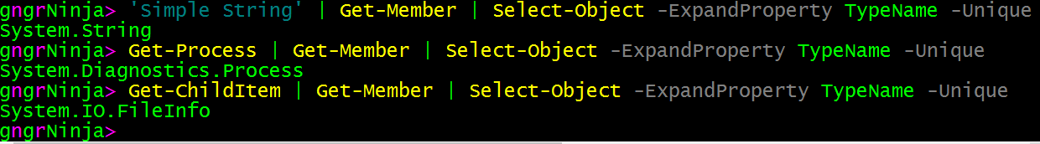

Custom objects are objects we create to collect data we want to collect. They can be comprised of objects from other datasets, arrays, and commands. Anything we can do in PowerShell can be fed into a custom object.

While we can create any type of object, from COM objects to objects based on .NET classes, we'll be focusing on the PSCustomObject. PSCustomObject is a .NET class **[**System.Management.Automation.PSCustomObject**]**.

**WHY CREATE CUSTOM OBJECTS?**

So that's nice... we can create custom objects, but why do it? Simple... output. In PowerShell it is best to keep your output from scripts and functions as objects you create or handle.  This allows for better readability and re-use.

That way you can collect information, and iterate through it with built in commands such as **Select-Object**and **Where-Object**.

Since we can add anything to a custom object, from any other object/source in PowerShell, it can also be used as a method to organize information.

Let's take a look at a few example of creating custom objects.

**CREATING CUSTOM OBJECTS**

Below I will be creating custom objects using various methods. It is important to understand that there isn't necessarily a best way to do anything in PowerShell. At the end of the day, the best way is the way that gets the job done for ***you***.

However, I tend to gravitate towards methods that are easy for people looking at my scripts to interpret. This applies even when I'm looking at my own scripts! If I'm tired, and looking at some of my code, the last thing I need to do is try to figure out what I was doing based on code that isn't that easy to read.

Feel free to follow along! Open up the ISE and save a file to C:\PowerShell named part12.ps1. I will use the following code each time an example executes:

$adminPasswordStatus = $null

$thermalState = $null

$osInfo = Get-CimInstance Win32_OperatingSystem

$computerInfo = Get-CimInstance Win32_ComputerSystem

$diskInfo = Get-CimInstance Win32_LogicalDisk

**Switch** ($computerInfo.AdminPasswordStatus) {

0 {$adminPasswordStatus = 'Disabled'}

1 {$adminPasswordStatus = 'Enabled'}

2 {$adminPasswordStatus = 'Not Implemented'}

3 {$adminPasswordStatus = 'Unknown'}

**Default** {$adminPasswordStatus = 'Unable to determine'}

}

**Switch** ($computerInfo.ThermalState) {

1 {$thermalState = 'Other'}

2 {$thermalState = 'Unknown'}

3 {$thermalState = 'Safe'}

4 {$thermalState = 'Warning'}

5 {$thermalState = 'Critical'}

6 {$thermalState = 'Non-recoverable'}

**Default** {$thermalState = 'Unable to determine'}

}

Be sure to include the code above with any example you want to try in the ISE.

**NEW-OBJECT WITH ADD-MEMBER**

With this method the first thing we'll do is create the object with the **New-Object** command, and store the object in a variable. Then we'll pipe the object to the **Add-Member** command. **Add-Member** will add the properties or methods we specify to the object we create.

We'll be using the **MemberType** of NoteProperty, and then give names to the properties (the names are whatever we want them to be). It's good to make them make sense! Then, finally, we'll define the **Value** as whatever expression we need to. In this case we'll use the some of the variables above. If you're following along and didn't catch what we have in the variables, check the summary below.

**$computerInfo** contains information from **Get-CimInstance** Win32_ComputerSystem.  
**$osInfo** contains information from **Get-CimInstance** Win32_OperatingSystem.  
**$diskInfo** contains information from **Get-CimInstance** Win32_LogicalDisk.

Here's the code:

$ourObject = New-Object -TypeName psobject

$ourObject **|** Add-Member -MemberType NoteProperty -Name ComputerName -Value $computerInfo.Name

$ourObject **|** Add-Member -MemberType NoteProperty -Name OS -Value $osInfo.Caption

$ourObject **|** Add-Member -MemberType NoteProperty -Name 'OS Version' -Value $("$($osInfo.Version) Build $($osInfo.BuildNumber)")

$ourObject **|** Add-Member -MemberType NoteProperty -Name Domain -Value $computerInfo.Domain

$ourObject **|** Add-Member -MemberType NoteProperty -Name Workgroup -Value $computerInfo.Workgroup

$ourObject **|** Add-Member -MemberType NoteProperty -Name DomainJoined -Value $computerInfo.Workgroup

$ourObject **|** Add-Member -MemberType NoteProperty -Name Disks -Value $diskInfo

$ourObject **|** Add-Member -MemberType NoteProperty -Name AdminPasswordStatus -Value $adminPasswordStatus

$ourObject **|** Add-Member -MemberType NoteProperty -Name ThermalState -Value $thermalState

Now let's run that, and then type **$ourObject** to see what our object contains.

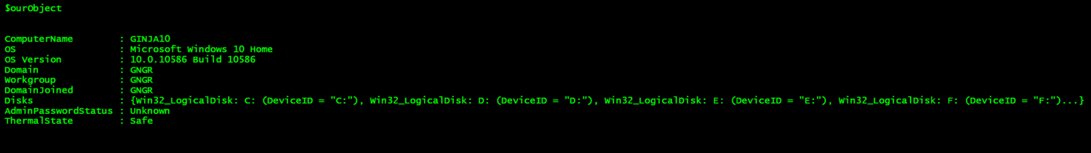

That worked! We created an object, which contains information from all three sources. We can type **$ourObject.Disks** to see what is contained there.

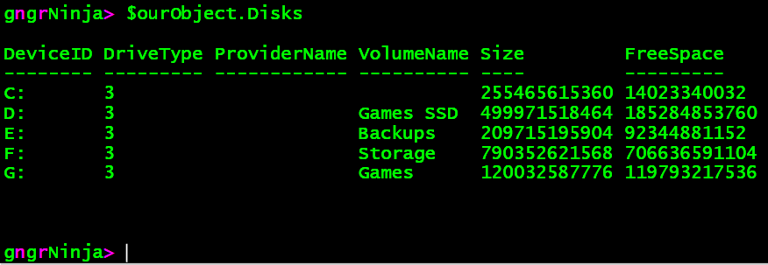

**HASHTABLE USING ADD METHOD**

Now let's take a look at using a hashtable to add our properties and values to the custom object. A hashtable is a collection of keys that have names with associated values.

For this example I will create the hashtable, and then call its **Add** method to add the pairs of data (separated by a comma). With this method we will actually create the object last, as we'll be adding the hashtable of properties and values to it when we create it.

If you're following along and didn't catch what we have in the variables, check the summary below.

**$computerInfo** contains information from **Get-CimInstance** Win32_ComputerSystem.  
**$osInfo** contains information from **Get-CimInstance** Win32_OperatingSystem.  
**$diskInfo** contains information from **Get-CimInstance** Win32_LogicalDisk.

Here's the code:

[hashtable]$objectProperty = @{}

$objectProperty.Add('ComputerName',$computerInfo.Name)

$objectProperty.Add('OS',$osInfo.Caption)

$objectProperty.Add('OS Version',$("$($osInfo.Version) Build $($osInfo.BuildNumber)"))

$objectProperty.Add('Domain',$computerInfo.Domain)

$objectProperty.Add('Workgroup',$computerInfo.Workgroup)

$objectProperty.Add('DomainJoined',$computerInfo.PartOfDomain)

$ObjectProperty.Add('Disks',$diskInfo)

$objectProperty.Add('AdminPasswordStatus',$adminPasswordStatus)

$objectProperty.Add('ThermalState',$thermalState)

$ourObject = New-Object -TypeName psobject -Property $objectProperty

Now let's see what **$ourObject** contains.

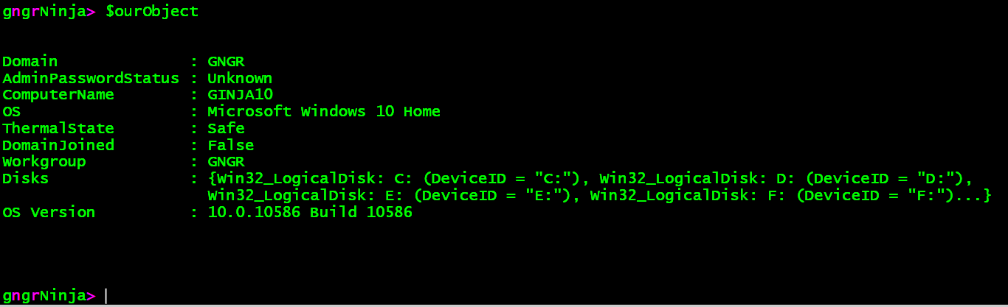

The code looks cleaner, but notice the order of the properties! It's not in the order we created the hashtable in. With **Add-Member** we were able to add each property, and it would keep the order we added them in.

That's not really a big deal, though! Since PowerShell has the nifty **Select-Object** command, we have an easy way to re-order the object.

Let's try:

$ourObject **|** Select-Object ComputerName,OS,'OS Version',Domain,Workgroup,DomainJoined,AdminPasswordStatus,ThermalState,Disks

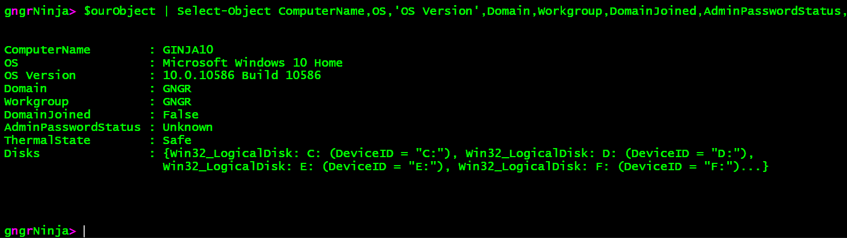

There we go, the order is as we want it now. Note that this will work to re-order any object you pass to it, and this can really come in handy.

**ORDERED HASHTABLE**

**!NOTE!** Using this method is only supported in PowerShell version 3.0+

In this example I will declare the hashtable all at once, and then add the hashtable to the custom object we create. I will also use an ordered hashtable, so we can see how those work. That should allow us to keep the order of the properties correctly in the object.

Here's the code:

$objectProperty = [ordered]@{

ComputerName = $computerInfo.Name

OS = $osInfo.Caption

'OS Version' = $("$($osInfo.Version) Build $($osInfo.BuildNumber)")

Domain = $computerInfo.Domain

Workgroup = $computerInfo.Workgroup

DomainJoined = $computerInfo.PartOfDomain

Disks = $diskInfo

AdminPasswordStatus = $adminPasswordStatus

ThermalState = $thermalState

}

$ourObject = New-Object -TypeName psobject -Property $objectProperty

$ourObject

Let's run this **[**F5**]**, and see what happens!

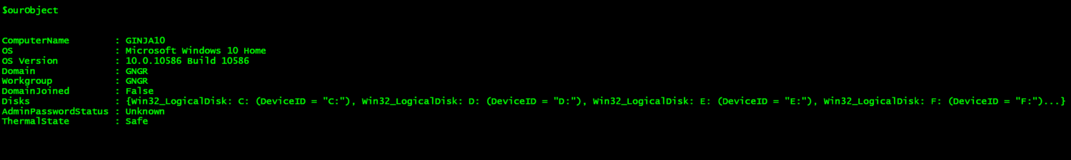

Looks good, and it is indeed in the right order!

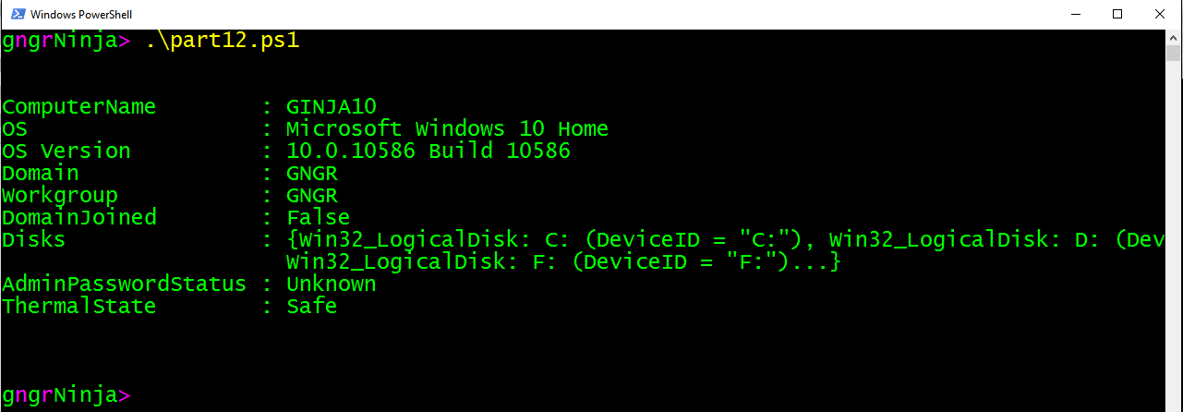

Running the script from the console shows the object in the correct order as well.

**PSCUSTOMOBJECT TYPE ADAPTER**

**!NOTE!** Using this method is only supported in PowerShell version 3.0+

We can also create custom objects using the **[**PSCustomObject**]** type adapter.

If you're following along and didn't catch what we have in the variables, check the summary below.

**$computerInfo** contains information from **Get-CimInstance** Win32_ComputerSystem.  
**$osInfo** contains information from **Get-CimInstance** Win32_OperatingSystem.  
**$diskInfo** contains information from **Get-CimInstance** Win32_LogicalDisk.

Here's the code:

$ourObject = [PSCustomObject]@{

ComputerName = $computerInfo.Name

OS = $osInfo.Caption

'OS Version' = $("$($osInfo.Version) Build $($osInfo.BuildNumber)")

Domain = $computerInfo.Domain

Workgroup = $computerInfo.Workgroup

DomainJoined = $computerInfo.PartOfDomain

Disks = $diskInfo

AdminPasswordStatus = $adminPasswordStatus

ThermalState = $thermalState

}

Let's take a look at **$ourObject**.

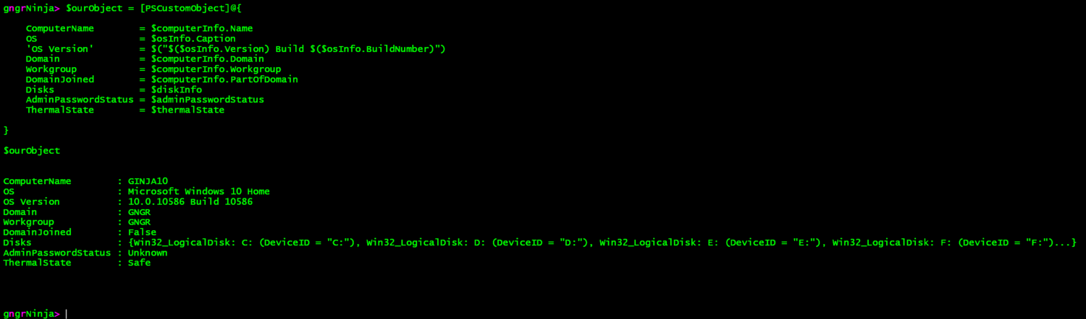

Nice! It also kept our order both in the ISE, and the console.

Here are the results from running part12.ps1 in the console:

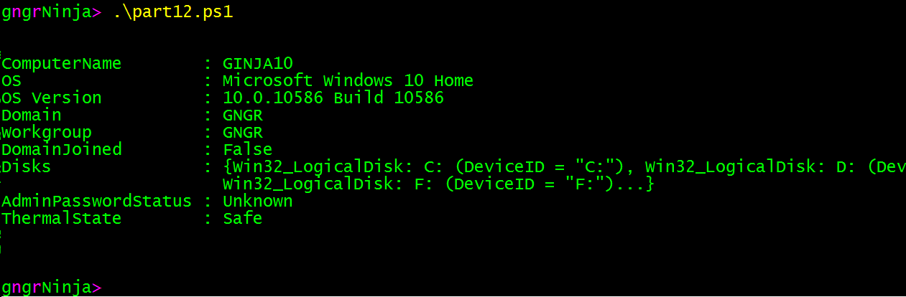

Same result. Now let's look at how we can use this code to create an array of custom objects.

**CREATING A CUSTOM OBJECT ARRAY**

Why would we want to do such a thing?

**Let's look at the following scenario:**

You have a list of computers that you need to get information from. You want to capture any error messages that may come up. You also would like to capture what the computer name in the file was (which we will as ComputerInput), as well as the computer name returned when querying for information. We'll also want to gather the operating system and disk information.

To do this, we can use a ForEach loop, which calls a function, and utilize Try/Catch for error handling.

We'll also use a lot of what we learned today about creating custom objects.

**Setup**

There is some setup to this, which is not included in the code.

**$credential**contains a **[**System.Management.Automation.PSCredential**]** object, which stores the credentials to access my laptop for this example.

**$computers** contains an array of computer names to look up. For this example, I created a text file, and used **Get-Content**to import it into the **$computers** variable.

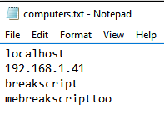

Looks like there are some potential script breakers in there!

**Let's look at the code:**

I've commented out the code to go over each and every step along the way.

**function** Get-ComputerInformation { #Begin function Get-ComputerInformation

[cmdletbinding()]

**param** (

[Parameter(

            Mandatory = $true

        )]

[String]

$computerName

)

**Try** { #Begin Try

#Using Write-Host as Verbose is too chatty with the other commands

Write-Host `n"Looking up information for: [$computerName]"`n

#Null out variables used in the function

#This isn't needed, but I like to declare variables up top

$adminPasswordStatus = $null

$thermalState = $null

$cimSession = $null

$computerObject = $null

$errorMessage = $null

#Except this guy, he gets a value that we'll use when errors are encountered

$unableMsg = 'Unable to determine'

#Switch out the incoming $computerName

#If it's localhost, we wont need to use our $credential variable when creating our CimSession

#This creates the $cimSession variable, which encapsulates the object created with New-CimSession pointed at the target $computerName

**Switch** ($computerName) {

'localhost' {$cimSession = New-CimSession -ComputerName $computerName -ErrorAction Stop}

**Default** {$cimSession = New-CimSession -Credential $credential -ComputerName $computerName -ErrorAction Stop}

}

#Gather information using Get-CimInstance, pointed to our $cimSession variable

#ErrorAction is set to Stop here, so we can catch any errors

$osInfo = Get-CimInstance Win32_OperatingSystem -CimSession $cimSession -ErrorAction Stop

$computerInfo = Get-CimInstance Win32_ComputerSystem -CimSession $cimSession -ErrorAction Stop

$diskInfo = Get-CimInstance Win32_LogicalDisk -CimSession $cimSession -ErrorAction Stop

#Use a switch to get the text value based on the number in $computerInfo.AdminPasswordStatus

**Switch** ($computerInfo.AdminPasswordStatus) {

0 {$adminPasswordStatus = 'Disabled'}

1 {$adminPasswordStatus = 'Enabled'}

2 {$adminPasswordStatus = 'Not Implemented'}

3 {$adminPasswordStatus = 'Unknown'}

**Default** {$adminPasswordStatus = 'Unable to determine'}

}

#Use a switch to get the text value based on the number in $computerInfo.ThermalState

**Switch** ($computerInfo.ThermalState) {

1 {$thermalState = 'Other'}

2 {$thermalState = 'Unknown'}

3 {$thermalState = 'Safe'}

4 {$thermalState = 'Warning'}

5 {$thermalState = 'Critical'}

6 {$thermalState = 'Non-recoverable'}

**Default** {$thermalState = 'Unable to determine'}

}

#Create the object, cleanly!

$computerObject = [PSCustomObject]@{

ComputerInput = $computerName

ComputerName = $computerInfo.Name

OS = $osInfo.Caption

'OS Version' = $("$($osInfo.Version) Build $($osInfo.BuildNumber)")

Domain = $computerInfo.Domain

Workgroup = $computerInfo.Workgroup

DomainJoined = $computerInfo.PartOfDomain

Disks = $diskInfo

AdminPasswordStatus = $adminPasswordStatus

ThermalState = $thermalState

Error = $false

ErrorMessage = $null

}

#Close the CimSession

Remove-CimSession -CimSession $cimSession -ErrorAction Stop

#Return the object created

**Return** $computerObject

} #End Try

**Catch** { #Begin Catch

#Capture the exception message in the $errorMessage variable

$errorMessage = $_.Exception.Message

#Create our custom object with the error message

$computerObject = [PSCustomObject]@{

ComputerInput = $computerName

ComputerName = $unableMsg

OS = $unableMsg

'OS Version' = $unableMsg

Domain = $unableMsg

Workgroup = $unableMsg

DomainJoined = $unableMsg

Disks = $unableMsg

AdminPasswordStatus = $unableMsg

ThermalState = $unableMsg

Error = $true

ErrorMessage = $errorMessage

}

#Keeping Write-Host here for the colors! Hate all you want ;)

Write-Host `n"Error encountered [$errorMessage]!"`n -ForegroundColor Red -BackgroundColor DarkBlue

#Return the object created

**Return** $computerObject

#Stop processing commands

**Break**

} #End Catch

} #End function Get-ComputerInformation

#Create the array we'll add the objects to

[System.Collections.ArrayList]$computerArray = @()

#Iterate through each computer in $computers with a ForEach loop

**ForEach**($computer **in** $computers) {

#Use the Add method of the ArrayList to add the returned object from the Get-ComputerInformation function

#Piping this to Out-Null is important to suppress the result output from adding the object to the array

$computerArray.Add((Get-ComputerInformation -computerName $computer)) **|** Out-Null

}

#Display the contents of the array.

$computerArray

Let's fire up the console, run the script, and take a look at the results!

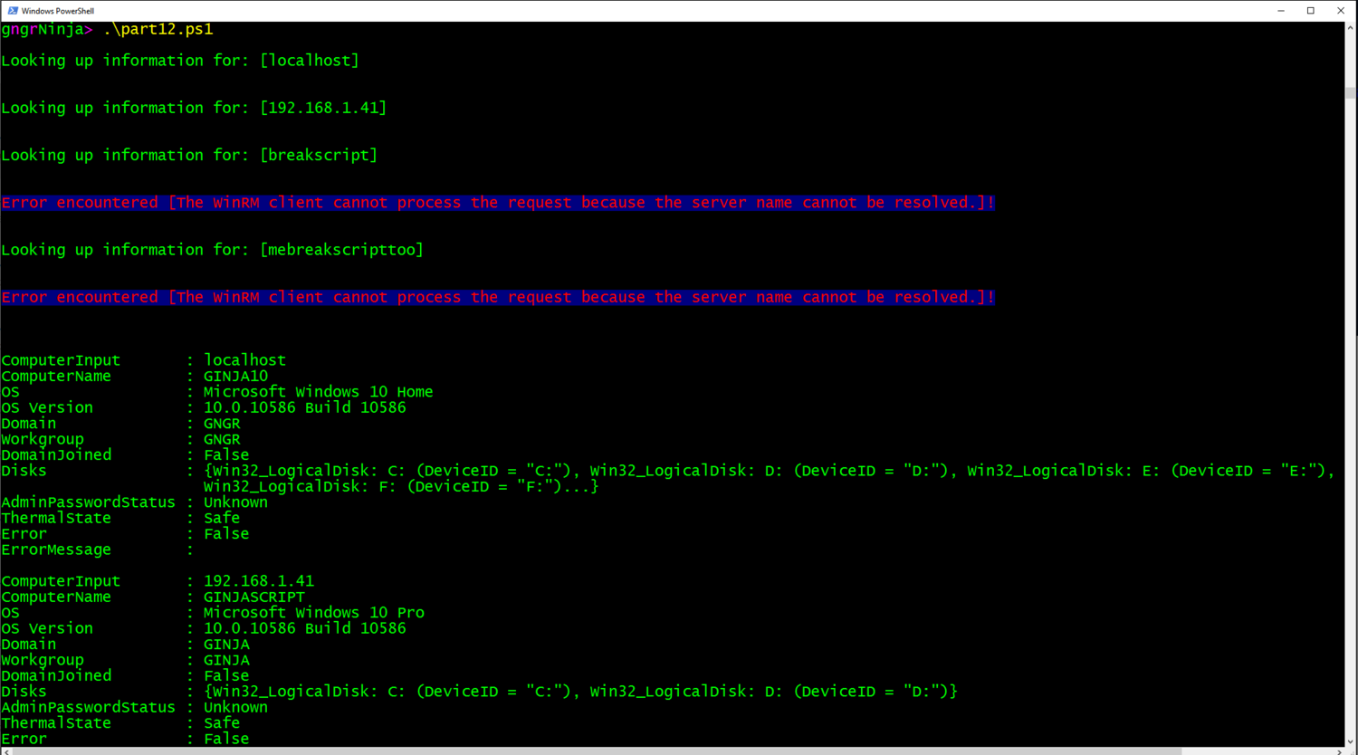

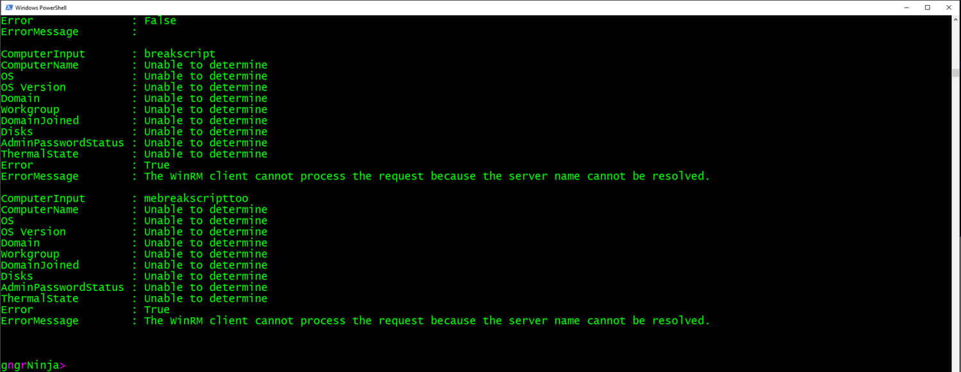

It looks like the returned object is indeed an array of objects we've created in the function.

To do this I created an array before I called the ForEach loop, and then used the Add method to call the function with the current **$computerName** in the loop. This returns the object as a result, when each loop iteration runs.

We can also create a variable to store the results of the script via:

$computerArray = .\part12.ps1

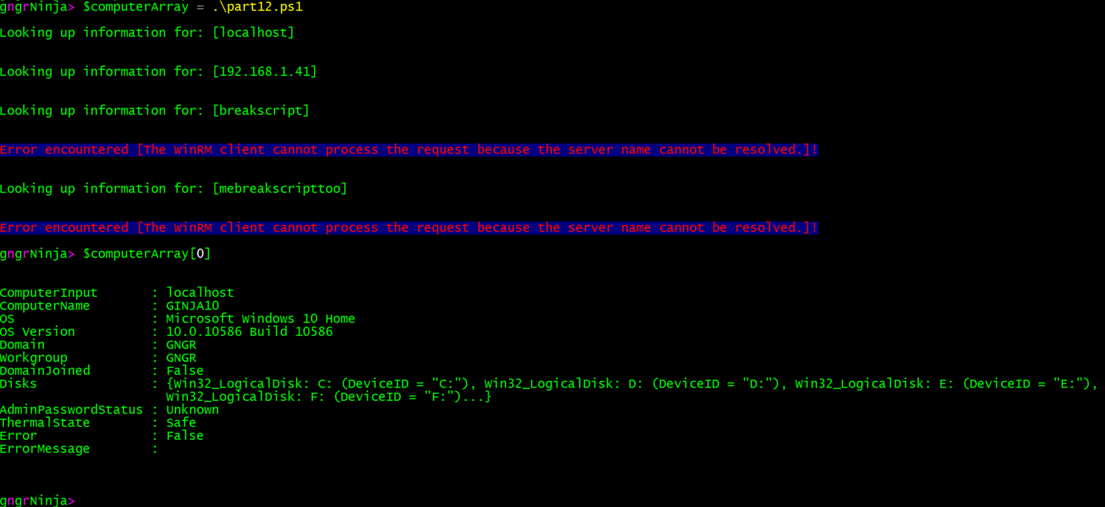

You can see that using **$computerArray[0]** returned the first object in the array.

Want to export this to a CSV? Use this command:

**$computerArray | Export-CSV .\results.csv -noTypeInformation**

https://static1.squarespace.com/static/5644323de4b07810c0b6db7b/t/57672fc846c3c42a38532f8d/1466380236073/?format=1500w

Let's open the file, and see if we were successful...



Now we can format it as we see fit!



**!Note!** Enumerating the disks and exporting them to the CSV is a bit more tricky as it is actually an object within an object.

This is but one of many ways to use objects! Again, there is no one right way. The right way is whatever works for you and your use case!

**HOMEWORK**

* How could you create a custom object that contains the computer name, along with network adapter, and IP information?
* What interesting ways could you combine error handling with custom objects?
* How can we properly export the disk information as well (from the custom object array example)?